PWM Signal Generation by Using AVR Timers. Part II

In this tutorial we will set up the TIMER0 in fast pwm mode and use it to generate PWM signals of varying duty cycles. In this way we would be generating analog signals of voltages between 0 and 5v. In the example we will connect this output to a LED and see how it varies its brightness. Please see the previous tutorials on PWM and TIMERs before reading this tutorial.
PWM
- Introduction to PWM - Pulse Width Modulation
- PWM Signal Generation with AVR Timers.
Timers
- Introduction To AVR Timers.
- Timers In Compare Mode Part I
- Timers In Compare Mode Part II

Setting Up TIMER0 in Fast PWM mode
Setting up the TIMER0 in fast pwm mode is very easy and just require one line of code. You only need to deal with one register named TCCR0 (Timer Counter Control Register For Timer 0). You just need to set up various bits in it to get the required setting. The various bits of TCCR0 is given below.

TCCR0
This register is used for configuring the TIMER0. See Timer Tutorial for more info. The explanation of various bits of this register is as follows.
Bit No | 7 | 6 | 5 | 4 | 3 | 2 | 1 | 0
Name | FOC0 | WGM00 | COM01 | COM00 | WGM01 | CS02 | CS01 | CS00
Initial Val | 0 | 0 | 1 | 0 | 0 | 0 | 0 | 0
(Note The Bits in RED are discussed here)
WGM - Wave Form Generation Mode
The table below shows the various modes supported by TIMER0. We have covered Normal mode in "Timer0 tutorial" and CTC mode in "Timers In compare mode" tutorial. And this tutorial we are interested in Fast PWM mode.
Mode | WGM00 | WGM01 | Mode Of Operation
0 | 0 | 0 | Normal
1 | 0 | 1 | PWM Phase Correct
2 | 1 | 0 | CTC
3 | 1 | 1 | Fast PWM
From the table it is clear that for Fast PWM we need mode 3. To get it we must set WGM00=1 and WGM01=1
COM - Compare Output Mode
These bits are used to set the Output mode in various Wave form generation mode. For Fast PWM mode these can be used to achieve following output modes.
COM01 | COM00 | Output Mode
0 | 0 | Normal Port Operation (OC0 disconnected)
1 | 0 | RESERVED
0 | 1 | Non Inverted PWM
1 | 1 | Inverted PWM
We need the "Non Inverted PWM output mode" so we set COM01=0 and COM00=1
CS - Clock Select
These are used to set an Input Clock for TIMER. We set them as follows to get Ftimer=F_CPU (i.e. no prescalling). See "Timer Tutorial" for more info.
CS02 = 0
CS01 = 0
CS00 = 1
Now the TIMER is in Fast PWM mode to vary its output duty cycle we just need to set the OCR0 (Output Compare Register for Timer 0). For example setting it to 0 will generate PWM with duty cycle 0% (Totally off) while setting it to 128 will generate 50% duty cycle and 255 will generate 100% duty cycle signals.
Note: The output waveform is available in the associated Output Compare Pin of the microcontroller. For example for Timer 0 the associated OC pin is OC0. You can find its location from Pin diagram in datasheet. In ATmega16 and ATmega32 it is on PORTB bit 3, i.e. PB3. This pin must be set to output to get the PWM signals.

Sample Program
The in the following program we set up TIMER0 in fast pwm mode and use the generated PWM signals to vary the brightness of a LED. This is the simplest program to get you started with PWM signal generation. We start with minimum brightness and increase it gradually and then again reduce it gradually to zero. This process is repeated as long as the system is powered.

#include <avr/io.h>
#include <util/delay.h>

void InitPWM()
{
/*
TCCR0 - Timer Counter Control Register (TIMER0)
-----------------------------------------------
BITS DESCRIPTION

NO: NAME DESCRIPTION
--------------------------
BIT 7 : FOC0 Force Output Compare [Not used in this example]
BIT 6 : WGM00 Wave form generartion mode [SET to 1]
BIT 5 : COM01 Compare Output Mode [SET to 1]
BIT 4 : COM00 Compare Output Mode [SET to 0]

BIT 3 : WGM01 Wave form generation mode [SET to 1]
BIT 2 : CS02 Clock Select [SET to 0]
BIT 1 : CS01 Clock Select [SET to 0]
BIT 0 : CS00 Clock Select [SET to 1]

The above settings are for
--------------------------

Timer Clock = CPU Clock (No Prescalling)
Mode = Fast PWM
PWM Output = Non Inverted

*/

TCCR0|=(1<<WGM00)|(1<<WGM01)|(1<<COM01)|(1<<CS00);

//Set OC0 PIN as output. It is PB3 on ATmega16 ATmega32

DDRB|=(1<<PB3);
}

/******************************************************************
Sets the duty cycle of output.

Arguments
---------
duty: Between 0 - 255

0= 0%

255= 100%

The Function sets the duty cycle of pwm output generated on OC0 PIN
The average voltage on this output pin will be

duty
Vout= ------ x 5v
255

This can be used to control the brightness of LED or Speed of Motor.
*********************************************************************/

void SetPWMOutput(uint8_t duty)
{
OCR0=duty;
}

/********************************************************************

Simple Wait Loop

*********************************************************************/

void Wait()
{
_delay_loop_2(3200);
}

void main()
{
uint8_t brightness=0;

//Initialize PWM Channel 0
InitPWM();

//Do this forever

while(1)
{
//Now Loop with increasing brightness

for(brightness=0;brightness<255;brightness++)
{
//Now Set The Brighness using PWM

SetPWMOutput(brightness);

//Now Wait For Some Time
Wait();
}

//Now Loop with decreasing brightness

for(brightness=255;brightness>0;brightness--)
{
//Now Set The Brighness using PWM

SetPWMOutput(brightness);

//Now Wait For Some Time
Wait();
}
}
}

Hardware Setup
To run and test this program you need an AVR MCU (ATmega16 or ATmega32)(ATmega8 won't work!). To keep the hardware simple we will use the MCU with internal 1MHz oscillator (this is default factory setting for new MCUs). We will add a good quality RED LED to output compare pin (OC0) of the MCU. This is PIN no 4 on ATmega16/32 Micros. Vcc PIN (pin 10) is connected to +5v and Gnd PIN(pin 11,31) is connected to gnd. This is not show in diagram.
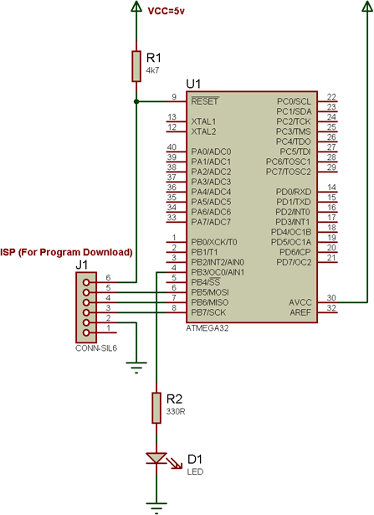

Fig. 1 - A PWM controlled LED

